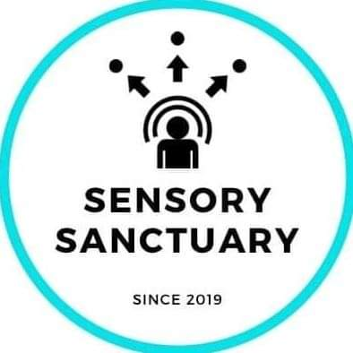 Sensory Sanctuary
A Nonprofit Organization
415 Dunlap Ave., P.O. Box 301, Savoy, IL, 61874, Tel. (217)855-8214
Email: hjohnston@sensorysanctuary.org Website: www.sensorysanctuary.org
Office Use Only
Payment Method: _________
Amount Paid: _________
Date Paid: _________
Voting: □
Volunteer: □
Donor: □

2021 Membership Application Form
Please read all information carefully
Eligibility
Applicants must be 18 or older and pass a background check.
Membership Categories
A member is classified as a voting member if they pay more for the right to vote on board members and other board activities.
A member is classified as a volunteer member if they pay for their membership with their time.
A member is classified as a donor member if they pay for their membership with money.
Membership periods and fees
See the membership options and fee schedule on page 2.

First name: ________________________________ Last Name: _____________________________________
Address: _________________________________________________________________________________
__________________________________________________________ Zip Code: ______________________
Date of Birth: _______ / ______ / _______ Sex (circle): Male / Female / Non-Binary / Other
Telephone: (home) ______________________________ (mobile) ____________________________________
Email ____________________________________________________________________________________
Do you have United States Citizenship? □ Yes □ No. Nationality if not US: __________________
Type of Participation (check all applicable) □ Voting □ Volunteer □ Donor □ Dual
I hereby apply for membership with Sensory Sanctuary Nonprofit Organization. I agree to be bound by and comply with the policies and rules of Sensory Sanctuary and declare that I am knowledgeable of and will comply with and be bound by the Sensory Sanctuary Non-Disclosure Agreement.

______________________________________ ________________________________
Signature of Applicant Date

Membership periods and fees

There are four membership options:
  - Voting Volunteer Membership – membership for 12 months with voting privileges towards new board members and important board activities, as long as the 100-hour volunteer annual minimum is met.
  - Voting Donor Membership – membership for 12 months with voting privileges towards new board members and important board activities, as long as the $500 annual minimum is met.
  - Voting Dual Membership – membership for 12 months with voting privileges towards new board members and important board activities, as long as the $250 and 50 hour minimums are both met.
  - Non-Voting Volunteer Membership – membership for 12 months without voting privileges so long as the 20-hour volunteer annual minimum is met.
  - Non-Voting Donor Membership – membership for 12 months without voting privileges so long as the $100 annual minimum is met.
  - Non-Voting Dual Membership – membership for 12 months without voting privileges so long as the $50 and 10 hour minimums are both met.

Schedule of Fees
Option 1: Annual Voting Membership
Volunteer 100 Hours
Donor $500
Dual 50 Hours and $250
Option 2: Annual Non-Voting Membership
Volunteer 20 Hours
Donor $100
Dual 10 Hours and $50
Please check your choice of voting status
- Voting
- Non-Voting

Please check your membership status

- Volunteer
- Donor
- Dual
Payment Details

Please check the method of payment

  - Cash enclosed
  - Local Check or Money Order enclosed (payable to Sensory Sanctuary)
  - Debit or Credit Card (you will be contacted to process payment)

